TECHNICAL WHITE PAPER
Bhagirath ERP
Architecture, Design and Operation
How the plant's manufacturing ERP works: its architecture, the design decisions behind it, the mechanisms that enforce quality and material flow, its data model, security, and how to run and extend it.

Version: 1.0 · Handover edition
Date: October 2026
Audience: Technical owner, developers
Classification: Internal · Confidential

Document control
Item | Detail
Title | Bhagirath ERP: Architecture, Design and Operation (Technical White Paper)
Version | 1.0, handover edition
Date | October 2026
System version | Database migration head g3b4c5d6e7f8
Audience | Technical project manager taking ownership; developers and analysts maintaining the system
Classification | Internal and confidential. Do not distribute outside the organisation.
Companion documents | Setup guide for Windows; setup guide for macOS; database export guide; summary of changes (before and after); docs/DATABASE_REFERENCE.md inside the project

Scope
This paper describes the complete system as delivered: the staff application, the shop-floor station screens, the dealer, vendor and maintenance portals, the REST API and the PostgreSQL database. It covers architecture, design rationale, the core mechanisms, data, security, code organisation, business processes, change impact, extension, operations and known limitations. Installation steps are in the separate setup guides.
Navigating this document. Every entry in the Contents is a link. In Word, open View > Navigation Pane to see the outline beside the text.

Contents
Executive summary
1. About this document
1.1 Purpose and audience
1.2 How to read it
1.3 Conventions
2. Business context
2.1 The plant
2.2 Problems the system solves
3. System overview
3.1 Users and portals
3.2 Capabilities
3.3 Technology
3.4 Deployment topology
4. Architecture
4.1 Architectural style
4.2 Back-end structure
4.3 Front-end structure
4.4 How a request flows
4.5 Cross-cutting concerns
5. Design decisions
D1. A modular monolith rather than microservices
D2. Asynchronous Python with FastAPI and SQLAlchemy 2
D3. One relational database with strong keys
D4. Permissions as data, with no hidden administrator bypass
D5. One table per dropdown list, indexed by a registry
D6. Station access by assignment, with permission fallback
D7. The QA gate as an explicit state machine table
D8. Routing by the chassis's own bill of material
D9. A frozen BOM snapshot per chassis
D10. Server-issued sequential document numbers
D11. Server state in React Query, one hook per API call
D12. Phone-first station screens on the same host
D13. A self-describing database
D14. Idempotent, reversible migrations
6. Core mechanisms
6.1 The chassis lifecycle
6.2 The QA-gated station hand-over
6.3 Next-station routing
6.4 Procurement check: exploding the bill of material
6.5 Stock consumption on QA pass
6.6 QA inspection lifecycle and concurrency
6.7 Permission resolution
6.8 Station access
6.9 Cycle time and overdue detection
6.10 Sequential document numbering
6.11 The configuration layer: changing behaviour without code
7. Data architecture
7.1 Overview
7.2 Naming conventions
7.3 Business areas
7.4 Where to find a value
7.5 Schema evolution
8. Security model
8.1 Authentication
8.2 Authorisation
8.3 Public surface
8.4 Secrets and network
9. Code reference
9.1 Repository layout
9.2 Back-end modules
9.3 Key functions
9.4 Screens
10. Business processes end to end
10.1 Order to chassis
10.2 Chassis inward
10.3 Induction and procurement
10.4 Production with QA gates
10.5 Final inspection and dispatch
10.6 Supporting processes
11. Change impact
12. Extending the system
12.1 Add a dropdown list
12.2 Add an API endpoint
12.3 Add a screen
12.4 Add a table or column
12.5 Change a status flow
13. Operations
13.1 Running
13.2 Back-up and restore
13.3 Upgrading
13.4 Monitoring
13.5 Moving to production hosting
14. Quality assurance
15. Limitations and recommendations
Appendix A. Glossary
Appendix B. Configuration reference
Appendix C. Status catalogue

Executive summary
Bhagirath ERP is the operating system of a bus body-building plant. It follows every customer chassis from the moment it arrives at the yard, through each production station and its quality gate, to the gate pass that lets the finished bus leave. Around that core it runs sales and dealer orders, bills of material, purchasing and stores, and three external portals for dealers, vendors and the maintenance team.
The system is a single web application backed by one PostgreSQL database. A React front end serves office screens and phone-first shop-floor screens; a FastAPI back end exposes a versioned REST API organised into 22 business modules; the database holds about 157 tables, each described in plain language inside the database itself.
Four ideas shape the design:
1. The chassis is the unit of work. Every process (inward, procurement, production, quality, dispatch) reads and writes against one record per chassis, and every movement is logged.
2. Quality is a gate, not a report. A chassis cannot be checked in at the next station until QA at the current station has passed every mandatory checksheet and released it. The gate is an explicit, auditable state machine.
3. Configuration lives in data, not code. Stations and their order, QA checksheets, dropdown lists, roles, permissions and station staff are all rows that administrators edit on screen. Most day-to-day changes need no developer and no redeployment.
4. The system explains itself. Tables carry descriptions, a generated reference lists every column, and permissions, statuses and flows are documented in this paper.
This paper explains how the system works, why it is built the way it is, and how its key mechanisms solve the plant's problems, so that a technical owner can operate, change and extend it with confidence.

1. About this document

1.1 Purpose and audience
This is the authoritative technical description of Bhagirath ERP at handover (October 2026). It is written for the technical project manager who owns the system, and for developers and analysts who will maintain it. It assumes familiarity with web applications and relational databases, but no prior knowledge of this system or of bus manufacturing.

1.2 How to read it
If you want to | Read
Understand the system in ten minutes | Executive summary, Chapter 3
Understand how it is built | Chapters 4 and 5
Understand the key algorithms and rules | Chapter 6
Find data in the database | Chapter 7
Understand security | Chapter 8
Locate a file or screen | Chapter 9
Follow a business process end to end | Chapter 10
Change something safely | Chapters 11 and 12
Run, back up and upgrade it | Chapter 13

1.3 Conventions
- monospace marks file names, table and column names, status values and commands.
- Status values are written in capitals, exactly as stored, for example READY_FOR_DISPATCH.
- Menu paths are written Group > Item, for example Setup > Station Staff.
- File paths are relative to the project folder (backend/..., frontend/...).
- Companion files inside the project: docs/DATABASE_REFERENCE.md (every table and column),
docs/SETUP_GUIDE_WINDOWS.md, docs/SETUP_GUIDE_MAC.md, backend/scripts/README.md.

2. Business context

2.1 The plant
A customer (usually a dealer acting for a school, company or transport operator) orders buses of a given model, body type, customer segment and seating layout, with optional features such as air conditioning, door types or fire-protection systems. The customer's bare chassis arrives at the plant yard. The plant then builds the body on it through a fixed sequence of stations (chassis preparation, floor and side structure welding, roof, structure QA, primer and top-coat painting, electrical wiring, flooring and panelling, seat fitment, glass and doors) and finishes with a final vehicle inspection (FVI), an air-conditioning (thermal) check and a gate pass.
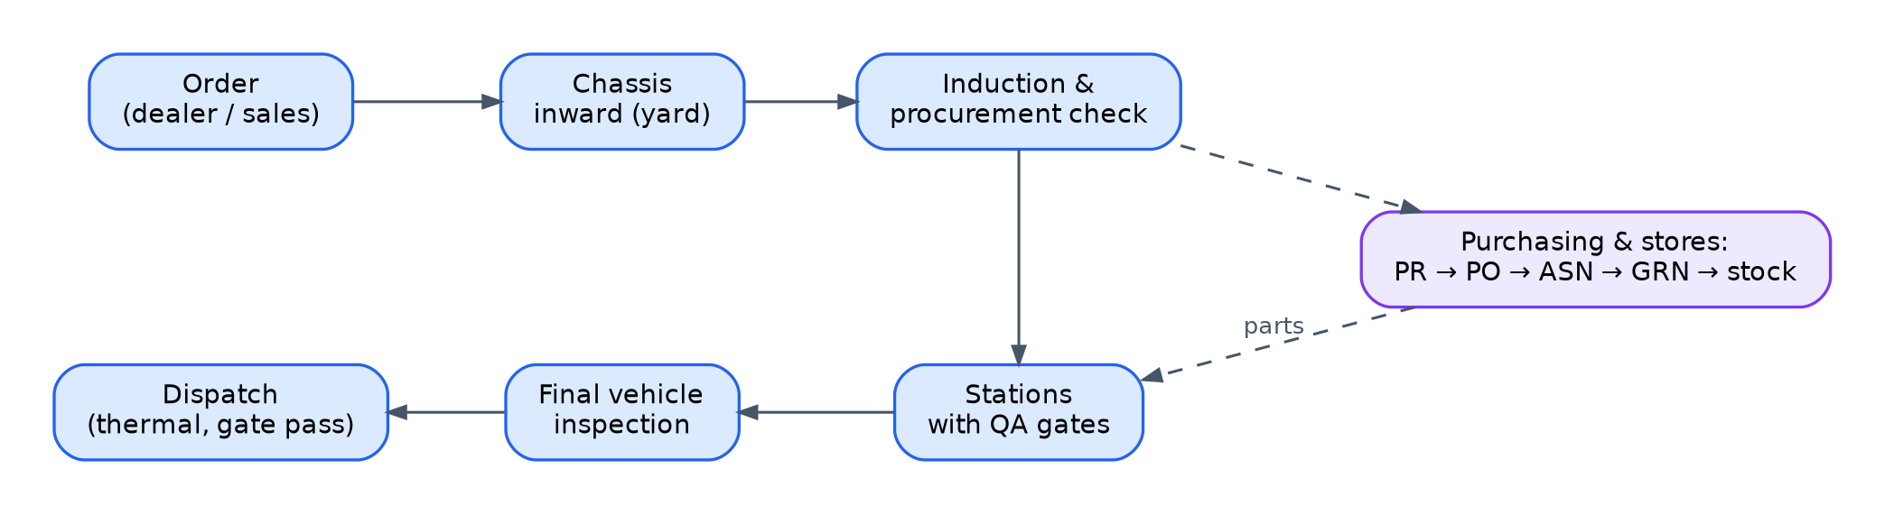
Figure 1. The value stream: from order to dispatch, with purchasing feeding parts to the stations.

2.2 Problems the system solves
Problem in the plant | How the system addresses it
Nobody could say where a given chassis was, or how long it had been there | Every check-in and completion is logged per station with timestamps; the Production Floor shows each station's chassis, elapsed time, age in days and overdue flags
Defects found late, after the chassis had moved on | QA-gated hand-over: the next station cannot accept a chassis until QA at the current station passes and releases it
Parts missing at the station when the chassis arrived | Procurement check per chassis: the order's full bill of material is exploded, stock reserved, shortages raised as purchase requests before production starts
Commercial holds (payment, documents) discovered at dispatch | DA-lite status recorded at inward; holds are visible to sales and on dashboards throughout
Paper checksheets, lost photos, unreadable remarks | Digital checksheets on phones with measurements, photos and remarks per checkpoint, section and checksheet
Dropdown values and station lists hard-coded by developers | Administrators maintain them on screen; values live in database tables
Dealers and vendors phoning for status | Dealer and vendor portals with their own logins; public QR tracking page per chassis

3. System overview

3.1 Users and portals
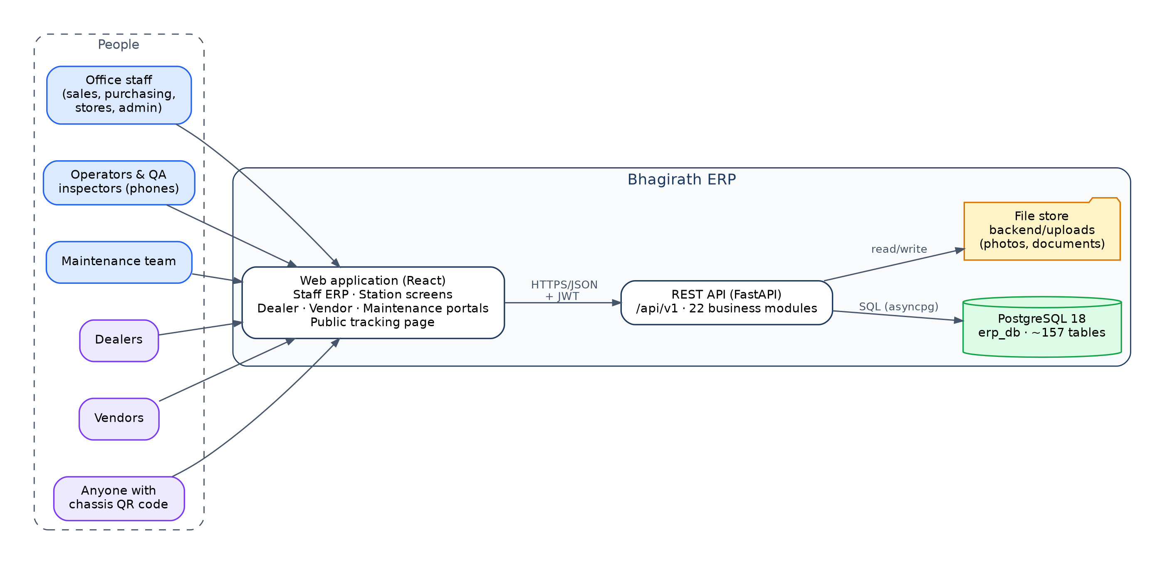
Figure 2. System context: who uses the system and its main parts.
Portal | Address | Users | Sign-in
Staff ERP | / | Office staff, supervisors, administrators | Staff account (login_users)
Station screens | /my-station, /qa/inspect | Operators and QA inspectors on phones | Staff account
Dealer portal | /dealer-portal | Dealers: orders, clients, chassis status | Dealer account (customer_master)
Vendor portal | /vendor-portal | Suppliers: purchase orders, shipping notices, rejections | Vendor account (vendor_master)
Maintenance portal | /maintenance-portal | Maintenance team | Staff account with MAINTENANCE permission
Public tracking | /track/<chassis no> | Anyone with the chassis QR code | None

3.2 Capabilities
Area | Capabilities
Chassis and yard | Chassis inward, arrival documents, DA-lite check with photo, yard QA checklist, movements between yard checkpoints, store hand-over sheet with approvals, hand-over to production, yard reports, QR tracking
Production | Induction scheduling, station check-in and completion from phones, live floor view, cycle-time warnings and overdue detection, delay reasons, holds, production report
Quality | Checksheet templates (sections, checkpoints, specifications), mapping to stations, phone inspections with photos and remarks, sign-off, QA gate and release, chassis QA history
Dispatch | Dispatch queue, thermal (AC) checksheet, gate pass
Sales | Dealers and clients, dealer order review and confirmation, chassis allocation, induction schedule, payments, goodwill approvals, spare parts and service orders, sales dashboard
Engineering | Vehicle models, body types, segments, special features and options, seating layouts, seat rules, base and feature bills of material
Purchasing and stock | Procurement engine, monthly plans, purchase requests and orders, goods receipt, debit notes, stock balances, movements, consumption, store requests
Administration | Users, roles, permission matrix, per-user overrides, station staff, dropdown lists, system logs

3.3 Technology
Layer | Technology
Database | PostgreSQL 18
Back end | Python 3.12, FastAPI, SQLAlchemy 2 (asynchronous, asyncpg driver), Pydantic 2, Alembic migrations
Front end | React 18, Vite, React Router, TanStack Query (React Query), Tailwind CSS, axios
Shop-floor scanning | html5-qrcode (phone camera), with typed or picked chassis as a fallback
Authentication | JSON Web Tokens (HS256), bcrypt password hashes

3.4 Deployment topology
In the current (local) deployment, three processes run on one computer: PostgreSQL on port 5432, the API on port 8000 and the front-end server on port 5173. Uploaded photos and documents are stored as files under backend/uploads and served by the API; the database stores only their paths. Phones on the same network reach the application at http://<computer address>:5173; the front end calls the API on the same host, port 8000.

4. Architecture

4.1 Architectural style
Bhagirath ERP is a modular monolith with a three-tier structure: a single-page web application, a single API process, and a single relational database. Business areas are separated into modules inside the API, each with its own routes, schemas and services, but they share one process, one database and one transaction model.
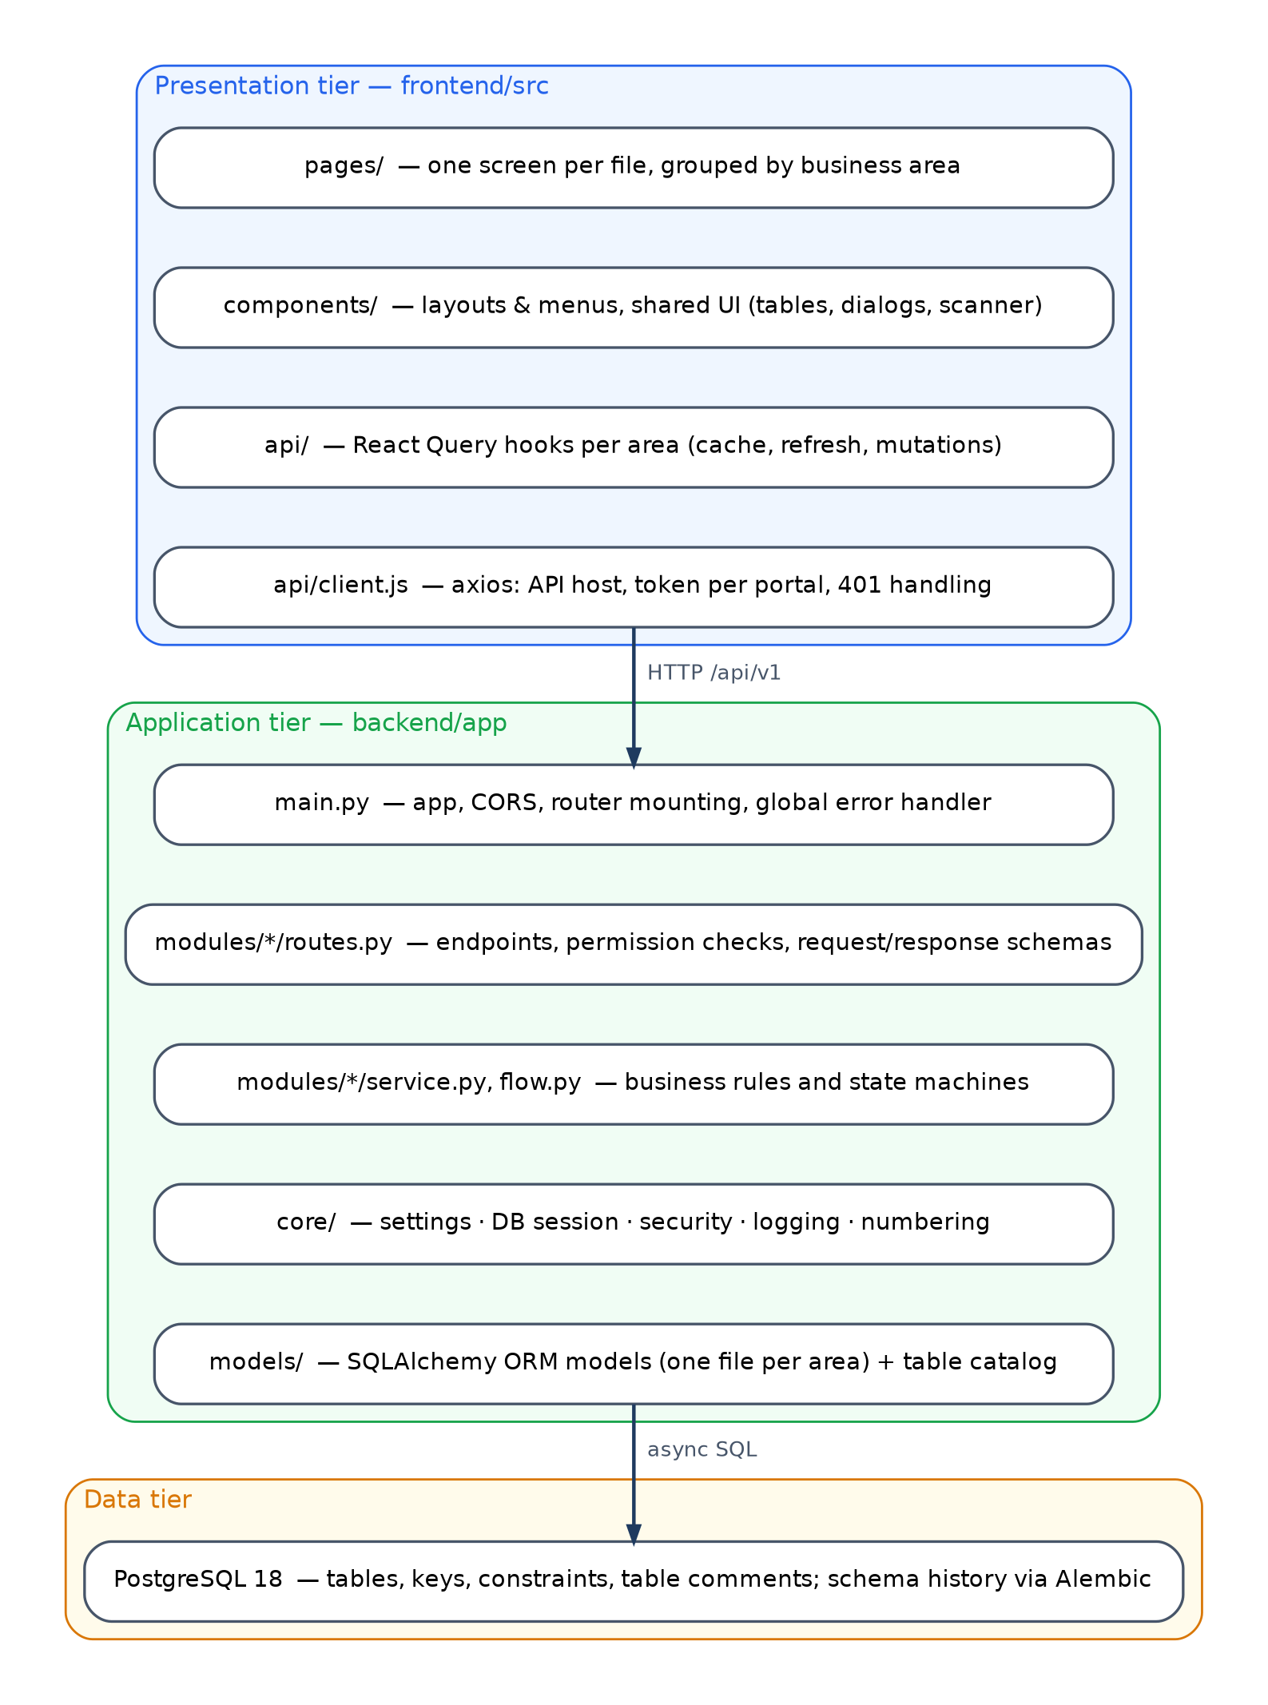
Figure 3. Layered architecture.
Tier | Responsibility | Location
Presentation | Screens, navigation, client-side caching, phone camera scanning | frontend/src
Application | Authentication, authorisation, business rules, state machines, validation | backend/app
Data | Persistent state, referential integrity, schema history | PostgreSQL, backend/migrations

4.2 Back-end structure
Each business module follows the same layering:
Layer | File | Holds
Interface | routes.py | Endpoint declarations, permission dependencies, request and response models
Domain | service.py (and flow.py for station work) | Business rules, state transitions, calculations
Contract | schemas.py | Pydantic models validating input and shaping output
Persistence | app/models/*.py | SQLAlchemy models mapped to tables

Cross-cutting services live in app/core: configuration (config.py), database engine and per-request session (database.py), authentication and authorisation (security.py), error logging (logging.py) and sequential document numbering (numbering.py).

4.3 Front-end structure
Layer | Location | Role
Routing | src/App.jsx | Maps every address to a screen, per portal; old addresses redirect
Shell | src/components/layout/* | Menus, top bar, phone tab bar; menu entries declare the permission module that shows them
Screens | src/pages/<area>/* | One file per screen
Data access | src/api/<area>.js | React Query hooks wrapping each API call; mutations refresh related data
HTTP | src/api/client.js | API host resolution, token per portal, sign-out on expired session
Shared UI | src/components/ui/* | Tables, dialogs, drawers, scanners, dropdowns bound to database lists

4.4 How a request flows
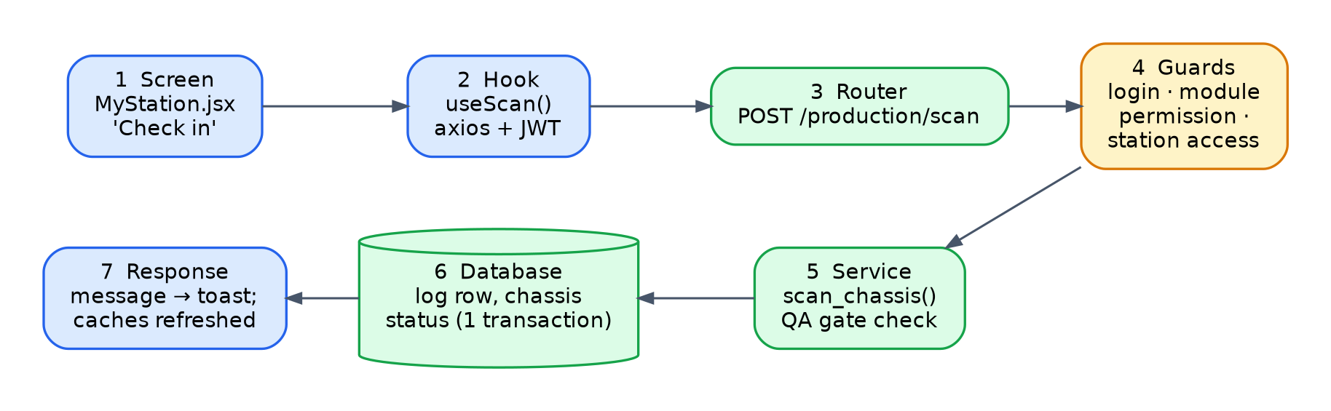
Figure 4. Life of a request: an operator checks a chassis in at a station.
1. The operator presses Check in on My Station. The screen calls the useScan hook.
2. The hook sends POST /api/v1/production/scan with the stored token.
3. FastAPI routes the request to the production module.
4. Dependencies run before the handler: the token is decoded and the user loaded; the PRODUCTION permission is checked; the station-access rule confirms the operator may work at that station.
5. scan_chassis applies the business rules, including the QA gate (Chapter 6.2), and writes a station log row and the chassis status.
6. The request's database session commits once, at the end. Any error rolls everything back.
7. The response carries a human-readable message; the front end shows it and React Query refreshes the station board.

4.5 Cross-cutting concerns
Concern | Mechanism
Transactions | One database session per request (get_db): commit on success, rollback on any exception, so a request is all-or-nothing
Validation | Pydantic schemas reject malformed input with HTTP 422 before business code runs
Errors | Business errors raise HTTPException with a readable detail shown to the user; unexpected errors are logged with full traceback to backend/logs/error.log and answered with a generic 500
Audit | Append-only log tables (chassis_status_log, chassis_station_log, portal action logs, permission audit)
Concurrency | Database advisory locks where two users can race (inspection start, document numbering)
Configuration | Environment file backend/.env; no secrets in code
API documentation | Generated live at /docs from the code

5. Design decisions
Each decision below records the context, the choice made, why, and its consequences. Together they explain why the system looks the way it does and what to preserve when changing it.

D1. A modular monolith rather than microservices
Context. One plant, one IT owner, tightly linked processes: a QA sign-off changes stock and production state in the same moment.
Decision. One API process and one database, split internally into business modules.
Rationale. Cross-area operations stay in a single database transaction, so they are consistent by construction. Operating one process is within reach of a small team.
Consequences. Simple to run and reason about. Modules share tables, so a schema change can affect several modules; Chapter 11 lists the main dependencies.

D2. Asynchronous Python with FastAPI and SQLAlchemy 2
Context. Many short requests from phones and office screens, largely waiting on the database.
Decision. FastAPI with async SQLAlchemy and the asyncpg driver.
Rationale. High concurrency per process, automatic request validation and live API documentation.
Consequences. Database access must use await; scripts that reuse the models run inside asyncio.run. The test suite shares one event loop across tests (pytest.ini).

D3. One relational database with strong keys
Context. Chassis, orders, parts and inspections are deeply interrelated and must stay consistent.
Decision. PostgreSQL with UUID primary keys, foreign keys, unique and check constraints; schema changes only through Alembic migrations.
Rationale. Integrity is enforced by the database, not only by the code; UUIDs can be generated anywhere without collisions.
Consequences. Deletes of referenced rows fail by design; masters are deactivated (is_active) instead of deleted.

D4. Permissions as data, with no hidden administrator bypass
Context. Roles and responsibilities change; the plant should not need a developer to change who can do what.
Decision. Every endpoint declares a module and action (require_permission('QA', 'approve')). Whether a user may do it is resolved from role_module_permission, with optional per-user overrides. The administrator role has no special case in code.
Rationale. One rule for everyone is easy to audit; the screen shows exactly what the server enforces, because the front end reads the same resolved permissions.
Consequences. Granting access is an on-screen change. Removing a row can lock out a role, including administrators, so changes to the ADMIN role need care.

D5. One table per dropdown list, indexed by a registry
Context. Seventeen dropdown lists were originally typed into the program.
Decision. Each list is its own *_master table with the same core columns (code, label, sort_order, is_active), and master_list_registry names every list and its table. A list can add typed columns of its own (for example the gate pass's default quantity and print row).
Rationale. Each list is visible and editable as a normal table, can carry list-specific columns with real types, and is discoverable through the registry, so one admin screen and one API serve all lists.
Consequences. Adding a list is a small migration plus one line of configuration (Chapter 12).

D6. Station access by assignment, with permission fallback
Context. Operators and inspectors should see only their stations; supervisors need to act anywhere.
Decision. station_user_assignment links users to stations as OPERATOR or QA. A user with assignments in a role is restricted to them; a user with none falls back to the module permission.
Rationale. Restriction is opt-in per person, so introducing assignments never locks supervisors out.
Consequences. Several assignments give one tab per station on the phone screens.

D7. The QA gate as an explicit state machine table
Context. Quality must be enforced between stations, and every decision must be traceable.
Decision. A dedicated table, chassis_station_handoff, holds one row per hand-over with an explicit status (AWAITING_QA, QA_PASSED, RELEASED, RECEIVED, SUPERSEDED), timestamps and the people involved. All transitions go through one module (station_work/flow.py).
Rationale. The gate's state is queryable and auditable at any moment, and the rules live in one place.
Consequences. Chassis already on the floor before the gate existed have no hand-over history and are deliberately not blocked.

D8. Routing by the chassis's own bill of material
Context. Not every chassis needs every station; a bus without, say, a particular fit-out has no parts for that station.
Decision. The next station is the next active station, by sequence, for which this chassis's frozen BOM has parts; if there is none, simply the next station in sequence.
Rationale. The route adapts to each order without a separate routing table to maintain.
Consequences. Part-to-station assignment (rm_master.station_id) directly affects routing.

D9. A frozen BOM snapshot per chassis
Context. Base BOMs and feature BOMs change over time; a chassis in production must keep the parts list it was planned with.
Decision. At the procurement check, the exploded BOM is written to chassis_bom_snapshot, with reserved and consumed quantities.
Rationale. Stock reservation, station routing and consumption all work from one stable list.
Consequences. Changing a BOM affects chassis checked afterwards; re-running the check for a chassis rebuilds its snapshot.

D10. Server-issued sequential document numbers
Context. Purchase order, goods receipt and debit note numbers were random numbers made in the browser, so duplicates were possible and numbers meant nothing.
Decision. The server issues PREFIX-YEAR-NNNNN numbers, serialised with a database advisory lock.
Rationale. Unique, ordered, human-readable numbers, safe under concurrent use.
Consequences. A user may still type a number; a blank field gets the next one.

D11. Server state in React Query, one hook per API call
Context. Many screens show the same data (chassis, stations, lists) and must stay current.
Decision. Screens never call the API directly; they use hooks from src/api, which cache data and refresh related queries after every change.
Rationale. Consistent loading and error handling, fewer requests, and screens that update themselves.
Consequences. When adding an API call, add a hook and invalidate the right query keys.

D12. Phone-first station screens on the same host
Context. Operators and inspectors work on the floor with phones.
Decision. Dedicated large-touch screens (My Station, QA Inspection); the front end calls the API on whatever host served the page, so the same build works on a desktop and on a phone on the plant network.
Rationale. No per-device configuration; the floor uses the same system as the office.
Consequences. Browsers allow the camera only on HTTPS pages, so camera scanning needs an HTTPS deployment; typed or picked chassis numbers always work.

D13. A self-describing database
Context. A new owner must be able to find data without reading code.
Decision. Every table carries a COMMENT written from app/models/table_catalog.py, and docs/DATABASE_REFERENCE.md is generated from the live schema.
Rationale. Documentation that lives with the data does not drift.
Consequences. When adding a table, add one line to the catalog and re-run two scripts.

D14. Idempotent, reversible migrations
Context. The database was originally built from a dump, then evolved by migrations.
Decision. Migrations check before creating (IF NOT EXISTS, existence queries) and provide a downgrade. alembic check verifies that models and database agree.
Rationale. Upgrades are safe to re-run and safe on databases restored from older dumps.
Consequences. New environments are built from a dump and then upgraded (Chapter 13).

6. Core mechanisms
This chapter explains the algorithms and rules that solve the plant's central problems.

6.1 The chassis lifecycle
A chassis carries several independent status fields, each owned by one part of the process. Reading them together tells you exactly where it stands.
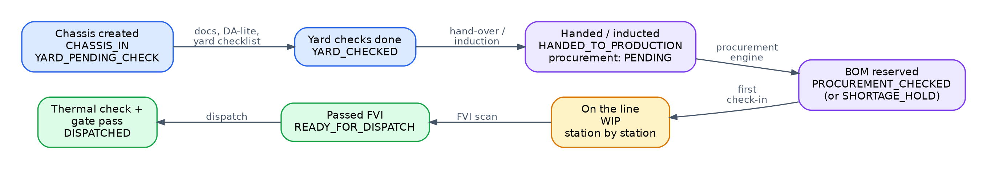
Figure 5. Chassis lifecycle across the status fields.
Field | Values | Set by
tracking_status | CHASSIS_IN → WIP → READY_FOR_DISPATCH → DISPATCHED | Yard (creation), first station check-in, FVI scan, dispatch
current_status | YARD_PENDING_CHECK → YARD_CHECKED → HANDED_TO_PRODUCTION | Yard checklist, hand-over or induction
procurement_status | PENDING → PROCUREMENT_PENDING → PROCUREMENT_CHECKED or SHORTAGE_HOLD | Induction, procurement engine
da_lite_status | PENDING, OK, HOLD | Yard DA-lite check
production_hold_status | NONE, ON_HOLD, RELEASED | Production holds

Every change of tracking_status is recorded in chassis_status_log with the user, time and location, giving a complete history.

6.2 The QA-gated station hand-over
Problem. Defects must be caught at the station that caused them, before the chassis moves on.
Mechanism. When an operator marks work complete at a station, a hand-over record is created to the next station. Its status decides whether the next station may accept the chassis.
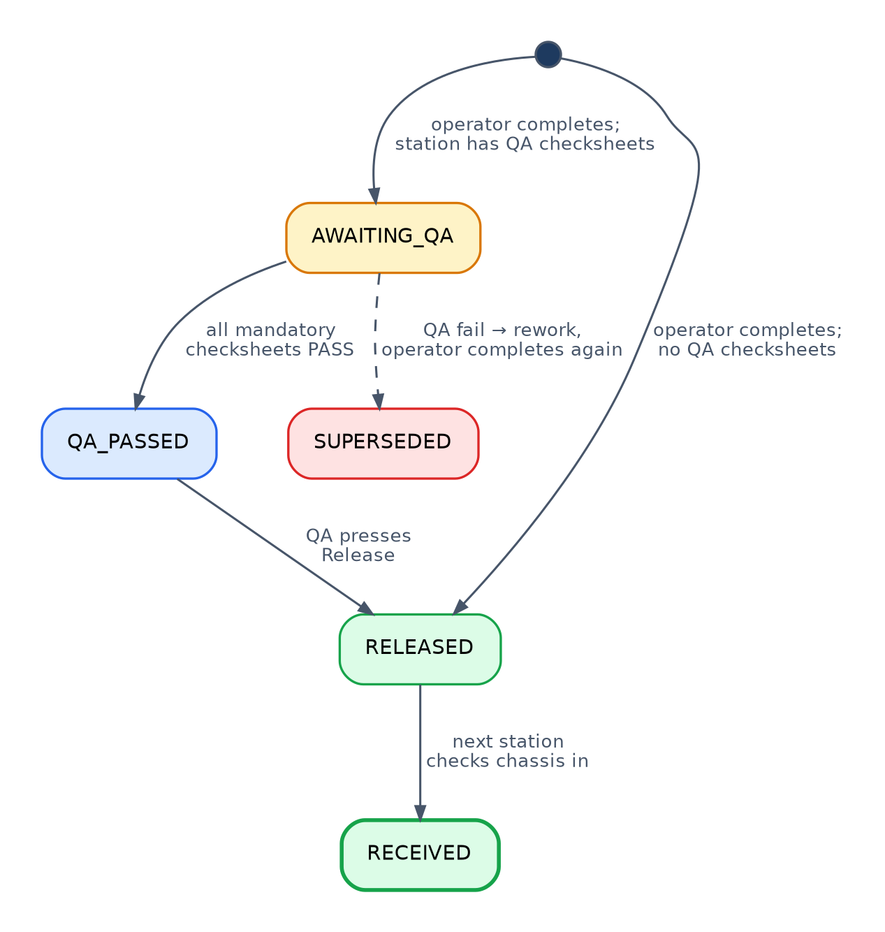
Figure 6. Hand-over states.
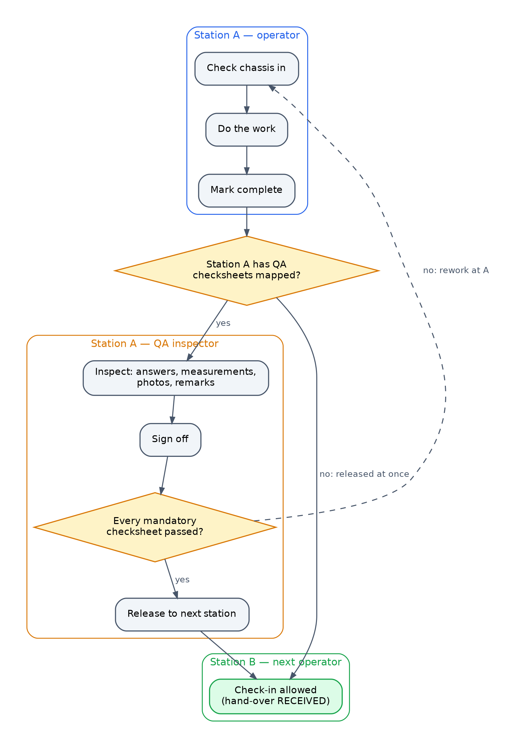
Figure 7. The QA gate as seen by operator, inspector and next station.
The rules, implemented in backend/app/modules/station_work/flow.py:
Event | Rule
Operator completes station A | If station A has QA checksheets mapped, create hand-over AWAITING_QA; otherwise create it RELEASED. Any earlier open hand-over from A for this chassis becomes SUPERSEDED.
QA signs off at station A | If every mandatory checksheet for this chassis at A has passed, the hand-over becomes QA_PASSED; if not, it stays AWAITING_QA and the operator reworks.
QA releases | QA_PASSED → RELEASED, recording who released it and when.
Operator at station B checks in | Allowed only if the chassis's latest hand-over is RELEASED to B (it then becomes RECEIVED), or if the chassis has no hand-over history at all. Otherwise refused with a message naming the reason.

Why it works. The gate is enforced on the server at check-in time, so no screen can bypass it; each transition is a timestamped row, so the history of every decision is preserved.

6.3 Next-station routing
Problem. Different orders need different stations.
Algorithm.
next_station(chassis, current):
candidates = active stations with sequence_no > current.sequence_no, in order
for station in candidates:
if chassis_bom_snapshot has a part for this chassis whose station is `station`:
return station
return first of candidates, or "end of line" if none
The station of a part comes from rm_master.station_id, copied into the plan when the procurement check runs.

6.4 Procurement check: exploding the bill of material
Problem. Know before production starts which parts each chassis needs and whether they are in stock.
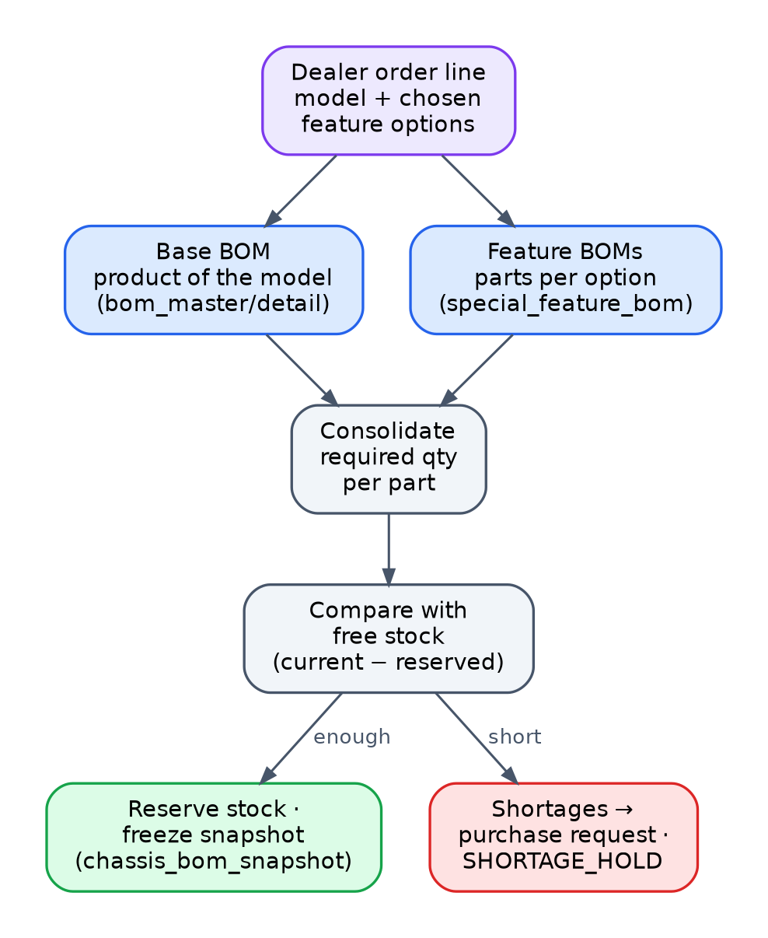
Figure 8. Procurement check for one chassis.
Algorithm (procurement/engine_service.py):
1. Take the order line behind the chassis: vehicle model and chosen feature options.
2. Base BOM: the product matching the model, and its bom_detail lines.
3. Feature BOMs: for each chosen option, its special_feature_bom lines.
4. Consolidate quantities per part.
5. For each part, free stock = current − reserved (rm_inventory). Report required, available and shortage per part (the *simulation* shown to the planner).
6. On confirmation: replace the chassis's chassis_bom_snapshot, reserve what stock allows, and turn shortages into purchase requests. The chassis becomes PROCUREMENT_CHECKED, or SHORTAGE_HOLD if anything is short.
A bulk variant (bulk_engine_service.py) runs the same logic for many chassis at once.

6.5 Stock consumption on QA pass
When QA passes a chassis at a station, the parts of its BOM snapshot assigned to that station are consumed from stock and the snapshot's consumed quantity is updated (qa/service.py, _deduct_inventory_on_qa_pass). Stock therefore moves when work is verified, not when it is planned.

6.6 QA inspection lifecycle and concurrency
1. Start. For a chassis at a station, the system finds the mapped checksheet templates (optionally restricted to some vehicle models or body types) and creates one inspection instance per template, or reopens existing ones. Two inspectors opening the same chassis at the same moment are serialised with a database advisory lock, so duplicate instances are not created.
2. Answer. Each checkpoint takes OK / NOT OK / NA, an optional measured value, a remark and photos. Answers are saved in bulk; photos are uploaded individually and do not discard unsaved answers.
3. Remarks. Remarks can be added per checkpoint, per section (qa_section_remark) and for the whole checksheet.
4. Sign-off. Records the outcome and reports whether all mandatory checksheets for this chassis and station have passed, which drives the hand-over (6.2).

6.7 Permission resolution
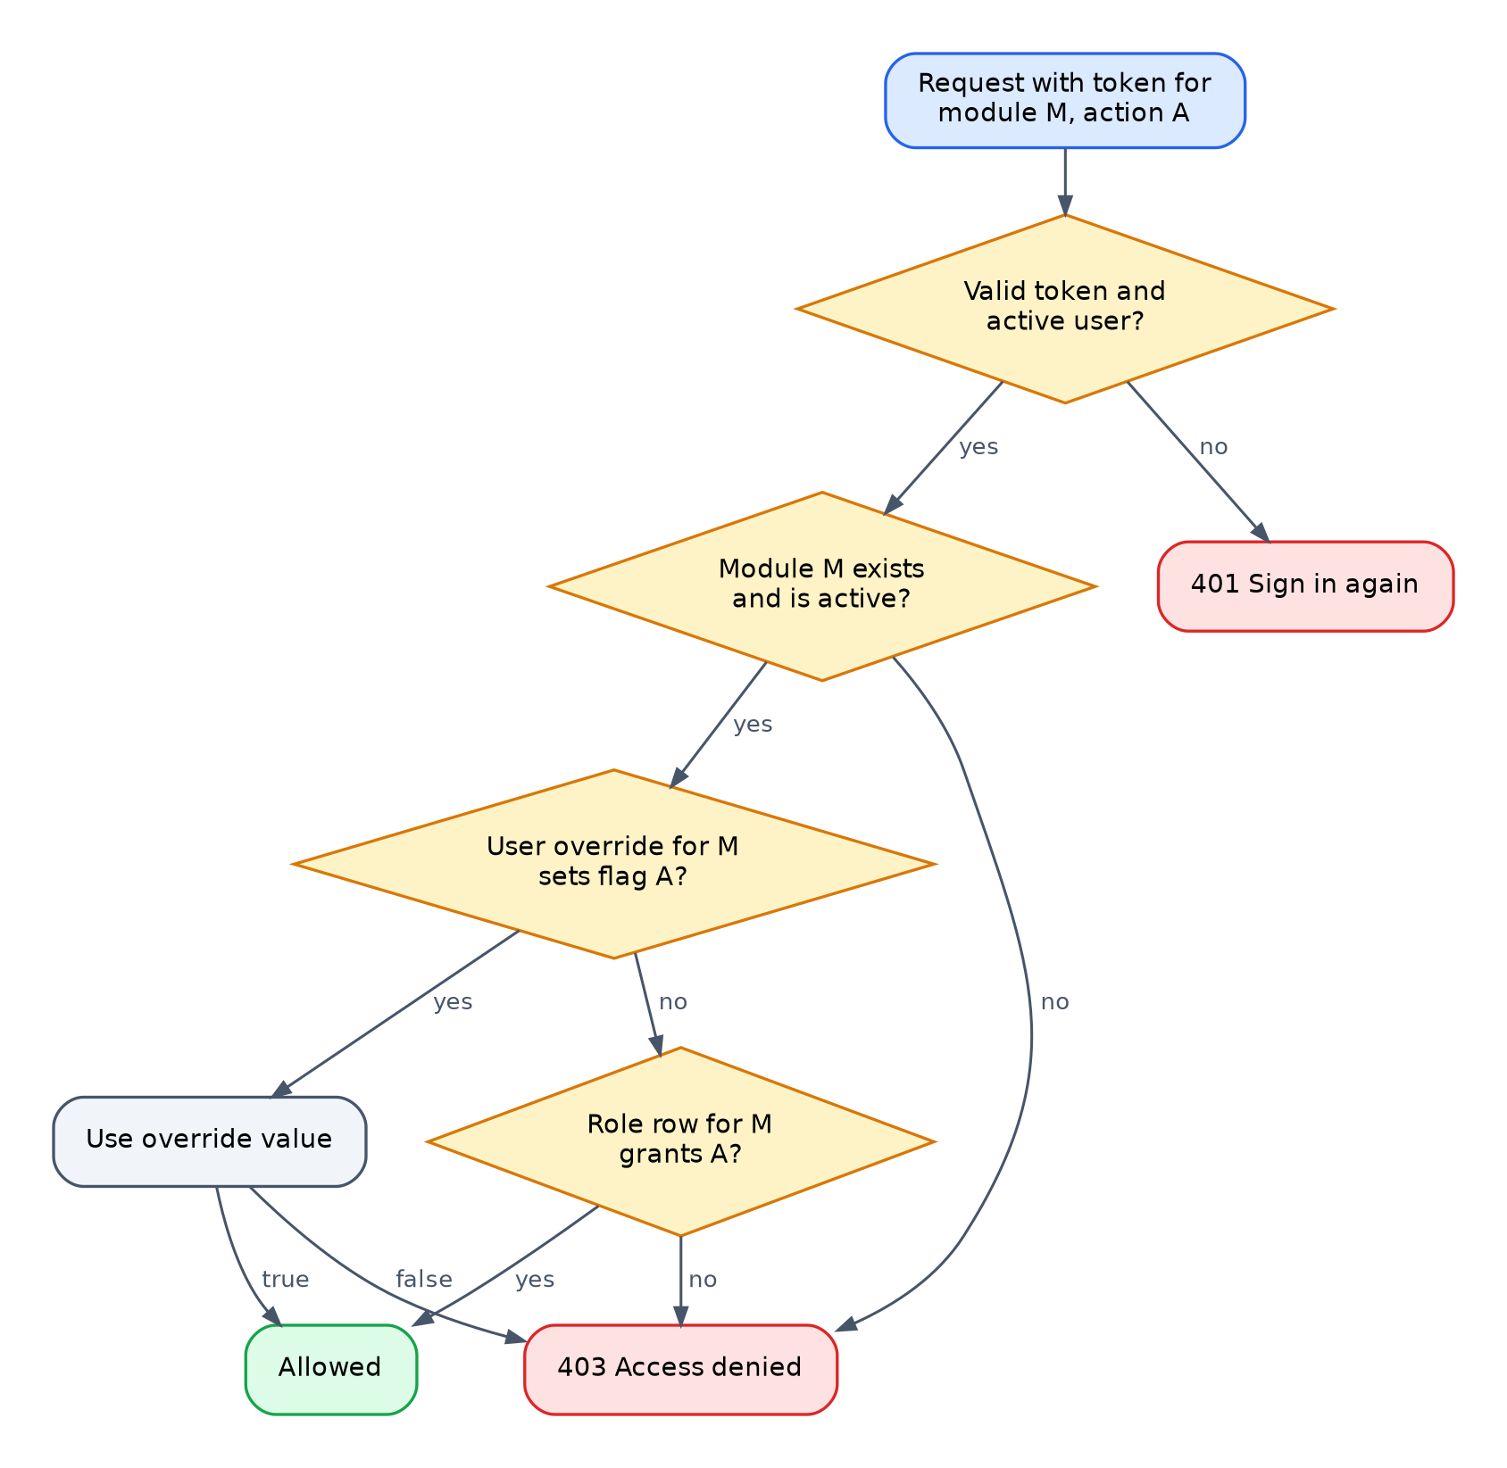
Figure 9. How the server decides whether a request is allowed.
The same resolution is exposed to the front end (GET /auth/me/permissions), which uses it to show or hide menu entries and buttons, so the screen always matches what the server enforces.

6.8 Station access
may_act(user, station, role): # role is OPERATOR or QA
assigned = stations assigned to user in this role
if assigned is not empty:
return station in assigned
return user has view permission on PRODUCTION (operator) or QA (inspector)

6.9 Cycle time and overdue detection
Each station defines a standard cycle time and an alert threshold in minutes (station_master.standard_cycle_time_min, alert_threshold_min). For every chassis currently at a station, elapsed time since check-in is compared with these values: above the threshold it shows a warning, above the cycle time it is overdue and can be given a delay reason (delay_reason_master). Durations are shown in days and hours once they pass a day.

6.10 Sequential document numbering
next_document_number(prefix): # e.g. "PO"
stem = prefix + "-" + current_year + "-"
take a transaction-level advisory lock on stem # serialises concurrent requests
highest = largest numeric suffix already issued with this stem
return stem + zero_padded(highest + 1, 5) # PO-2026-00042

6.11 The configuration layer: changing behaviour without code
Much of the system's behaviour is driven by data that administrators maintain on screen. This is the system's low-code layer.
What you configure | Where | Effect
Stations, their order, cycle times | Setup > Stations | The production line, routing, floor view, overdue detection
Who works at which station | Setup > Station Staff | Station tabs on phones; station access
QA checksheets and checkpoints | Quality > QA Checksheets | What inspectors check, which checkpoints are mandatory
Which checksheets run at which station | Quality > QA Checksheets > Station assignments | Whether a station has a QA gate, for which vehicles
Dropdown lists (17) | Setup > Production Masters > Dropdown Lists | Choices offered across the system
Vehicle models, body types, segments, features, seating | Setup > Production Masters | What can be ordered and configured
Base and feature BOMs | Setup > Bill of Materials | Parts planned per chassis, routing
Roles and permissions, per-user exceptions | Admin > Users & Access | Menus, buttons and API access
Delay reasons, hold types | Production Floor, Dropdown Lists | Reporting categories

7. Data architecture

7.1 Overview
The database erp_db (schema public) holds about 157 tables in 13 business areas. Every table has a description stored in the database (pgAdmin: select the table, Properties > Comment). The complete column-level reference is docs/DATABASE_REFERENCE.md.
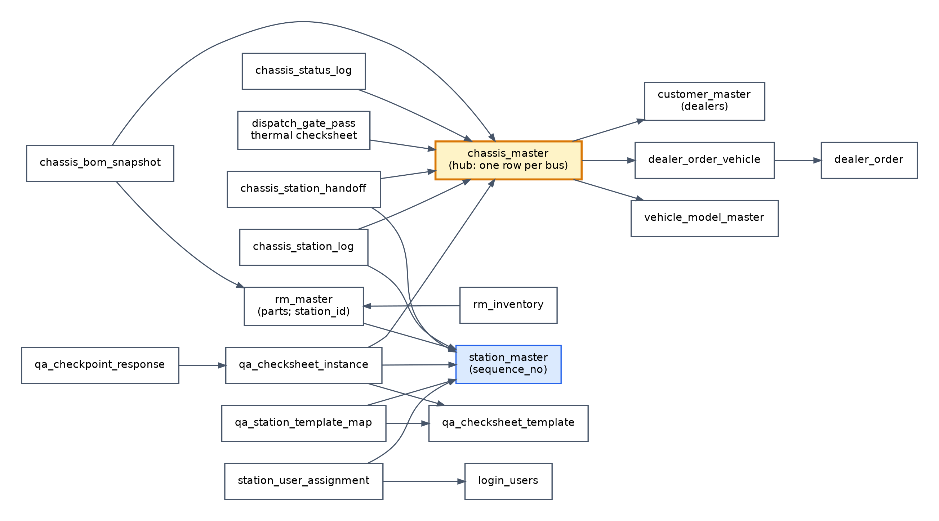
Figure 10. Core entities around the chassis.

7.2 Naming conventions
Pattern | Meaning | Example
*_master | Reference data maintained by administrators | station_master, ac_make_master
*_log | Append-only history, never edited | chassis_status_log
*_map, *_mapping | Link between two entities | qa_station_template_map
*_detail, *_item, *_line | Lines of a header document | rm_purchase_order_detail
<entity>_id | UUID primary key, reused as the foreign key name | chassis_id
is_active | Soft delete: hidden from pickers, kept for history
created_at, updated_at | Timestamps in UTC

7.3 Business areas
Area | Main tables | Hub
Users and access | login_users, role_master, module_master, role_module_permission, user_permission_override, station_user_assignment | login_users
Dropdown lists | master_list_registry and 17 *_master tables | master_list_registry
Plant layout | station_master, chassis_location_master, store_master, yard_checkpoint_master, yard_slot_master | station_master
Chassis and yard | chassis_master and its status, movement, document, checklist and hand-over tables | chassis_master
Production | chassis_station_log, chassis_station_handoff, production_hold, delay_reason_master, chassis_bom_snapshot | chassis_station_log
Quality | qa_checksheet_template → qa_checksheet_section → qa_checkpoint_item; qa_station_template_map; qa_checksheet_instance → qa_checkpoint_response → qa_response_photo; qa_section_remark; qa_checksheet_signoff | qa_checksheet_instance
Dispatch | dispatch_thermal_checksheet, dispatch_gate_pass and their items
Products and BOM | product_master, bom_master, bom_detail, special_feature_*, vehicle_model_master, body_type_master, customer_segment_master, seating_layout_master | bom_master
Sales and dealers | customer_master, dealer_client_master, dealer_order → dealer_order_vehicle → feature and chassis lines | dealer_order
Purchasing and stock | rm_master, rm_inventory, rm_inventory_log, purchase requests and orders, rm_receiving_log (GRN), vendor_master | rm_master
Vendor portal | asn_log, rejection_log, ncr_log, debit_note, vendor_scorecard
Maintenance | maintenance_* (14 tables) | maintenance_asset

7.4 Where to find a value
You want | Look in
A chassis and its state | chassis_master (search chassis_no); the five status fields in 6.1
Where a chassis is now | chassis_station_log with event_type = 'ARRIVAL' and status = 'AT_STATION'
Its station history and times | chassis_station_log ordered by scanned_at
Whether it may go to the next station | Its latest chassis_station_handoff row
Every status change | chassis_status_log
Its planned parts | chassis_bom_snapshot
Its QA results | qa_checksheet_instance → qa_checkpoint_response → qa_response_photo; qa_section_remark; qa_checksheet_signoff
Its order and dealer | dealer_order_vehicle_id → dealer_order_vehicle → dealer_order; dealer_id → customer_master
Values of a dropdown | master_list_registry names the table; the table holds code, label, sort_order, is_active
Station order | station_master.sequence_no (active rows)
Who works at a station | station_user_assignment
Which checksheets run at a station | qa_station_template_map
What a role may do | role_module_permission; exceptions in user_permission_override
Stock of a part | rm_inventory; movements in rm_inventory_log
Uploaded files | The row stores a path such as /uploads/qa/...; the file is under backend/uploads

7.5 Schema evolution
The schema is versioned with Alembic (backend/migrations/versions). The current head is g3b4c5d6e7f8. The handover-era revisions, in order:
Revision | Change
b2c3d4e5f6a8 | State of the original database dump
c7d8e9f0a1b2 | First version of administrator-managed dropdown values
e1f2a3b4c5d6 | 17 dropdown master tables and registry; station staff; QA photos
f2a3b4c5d6e7 | Station hand-over (QA gate); QA section remarks
g3b4c5d6e7f8 | Descriptions on every table

alembic upgrade head applies whatever a database is missing and is safe to repeat; alembic check confirms that code and database agree.

8. Security model

8.1 Authentication
Population | Mechanism
Staff | POST /auth/login with employee code or email and password, verified against a bcrypt hash; returns a signed JWT (HS256, key SECRET_KEY); valid for the configured period (30 days by default)
Dealers, vendors | Separate logins issue tokens bound to a session row (dealer_portal_log, vendor_portal_log); logout or expiry invalidates the session on the server
Maintenance team | Staff login, stored separately by the maintenance portal

The browser keeps the token in local storage and sends it as a bearer token on every call. An expired or invalid token returns 401 and the front end returns the user to the sign-in page.

8.2 Authorisation
Every protected endpoint declares its module and action; resolution is described in 6.7. Station actions add the station-access rule (6.8). There is no code path that grants access outside these rules.

8.3 Public surface
Only the sign-in endpoints, /health and the QR tracking endpoint (GET /api/v1/yard/track/{chassis_no}) answer without a token. The tracking endpoint returns status information only.

8.4 Secrets and network
Item | Handling
Database credentials, signing key | Only in backend/.env, never in code or in the repository; .env.example is the template
Seed passwords for demo data | Supplied as environment variables when running seed scripts
Cross-origin access | Allowed origins listed in ALLOWED_ORIGINS; ALLOWED_ORIGIN_REGEX admits private network addresses so phones on the plant Wi-Fi can use the app
Transport | The local deployment uses HTTP. A production deployment should use HTTPS (Chapter 13), which also enables camera scanning on phones

9. Code reference

9.1 Repository layout
backend/
app/main.py application, CORS, routers under /api/v1, uploads, error handler
app/core/ settings, database, security, logging, numbering
app/models/ ORM models per area; table_catalog.py (table descriptions)
app/modules/ one folder per business module
migrations/ Alembic schema history
scripts/ seed and Excel import scripts, table comments, DB reference generator
tests/ automated tests
uploads/ uploaded files (back up with the database)
frontend/
src/App.jsx all routes
src/api/ API hooks per area; client.js
src/components/ layouts, shared UI, station and QA components
src/pages/ screens by area
docs/ this paper's companions: setup guides, database reference
scripts/ macOS setup and start scripts

9.2 Back-end modules
All routes are under /api/v1. The live list with request and response shapes is at /docs on the running API.
Module | Prefix | Responsibility
auth | /auth | Sign-in, current user and permissions, administrator "view as vendor or dealer"
access_control | /access-control | Users, roles, permission matrix, audit logs
lookups | /lookups | Dropdown lists (registry and master tables)
station | /stations | Station master
station_work | /station-work | Station staff, operator and QA station boards, QA release; flow.py holds the hand-over state machine
yard | /yard | Chassis inward to hand-over, documents, DA-lite, checklists, movements, reports, tracking, production report
production | /production | Station scan, floor dashboard, timeline, overdue, delays, holds, analytics
qa | /qa | Checksheet templates, station mapping, inspections, photos, remarks, sign-off, history
dispatch | /dispatch | Dispatch queue, thermal checksheet, gate pass
sales | /sales | Dashboard, customers, clients, transporters, induction, payments, goodwill, spare parts, service orders
dealer_portal | /dealer-portal | Dealer self-service
dealer_portal_admin | /admin/dealer-portal | Staff review, confirmation, chassis allocation
production_masters | /production-masters, /bom-analysis | Vehicle masters, features, seating; BOM coverage
bom | /bom | Products, BOMs, feature BOMs
rm_master, vendor, store, inventory | /rm-master, /vendors, /stores, /inventory | Parts, suppliers, stores, stock
procurement | /procurement | Procurement engine, purchase requests and orders, goods receipt, debit notes, monthly plans
vendor_portal, vendor_portal_admin | /portal, /admin/vendor-portal | Vendor self-service and access
maintenance | /maintenance | Maintenance portal

9.3 Key functions
Function | File | Purpose
scan_chassis | production/service.py | Station check-in and completion; QA gate enforcement; cycle time
next_station, check_arrival, on_completion, set_qa_outcome, release | station_work/flow.py | Hand-over state machine
start_inspection, submit_responses_bulk, signoff_instance | qa/service.py | Inspection lifecycle
_deduct_inventory_on_qa_pass | qa/service.py | Stock consumption at QA pass
simulate_check, confirm_reservation | procurement/engine_service.py | BOM explosion, reservation, shortages
create_chassis, update_da_lite, handover_to_production, station_scan | yard/service.py | Chassis inward to dispatch statuses
induct_chassis_to_production | sales/routes.py | Induction
build_dashboard | sales/dashboard.py | Sales dashboard figures
user_has_permission, require_permission | core/security.py | Authorisation
next_document_number | core/numbering.py | Document numbers

9.4 Screens
Menu group | Screens (file under frontend/src/pages)
Chassis & Yard | Chassis Inward (yard/YardList, YardChassisDetail), Station Scanner, Parts Approvals, Dispatch Queue (dispatch/*), Yard Reports
Production | My Station (station/MyStation), Production Floor (production/ProductionDashboard), Production Schedule (sales/InductionReady), Production Report
Quality | QA Inspection (qa/QaInspect), Quality Dashboard, QA Checksheets (qa/TemplateManager, StationChecklistConfig), Chassis QA History
Sales & Orders | Sales Dashboard, Dealer Orders, Dealer Requests, Service Requests (sales/*)
Purchasing | Monthly Planning, Material Requirements (procurement/ProcurementEngine), Purchase Orders, Goods Received, Debit Notes
Stock | Stock Balance, Stock Movements, Record Material Use, Store Requests (inventory/*)
Setup | Dealers, Vendors, Transporters, Raw Materials, Stores, Stations, Station Staff, Vehicle Templates, Bill of Materials, Production Masters
Admin | Users & Access (admin/AccessControl), System Logs
Portals | dealer-portal/*, vendor-portal/*, maintenance-portal/*; tracking page yard/ChassisTrackingPage

10. Business processes end to end

10.1 Order to chassis
1. A dealer places an order in the dealer portal, or sales records it: order, vehicle lines, chosen features.
2. Sales reviews and confirms it (Sales & Orders > Dealer Orders); the dealer acknowledges any changes; sales gives final confirmation (CONFIRMED).
3. Chassis are allocated to the order lines.

10.2 Chassis inward
Chassis & Yard > Chassis Inward.
1. Create the chassis: number, model, dealer, fuel, arrival details (CHASSIS_IN, YARD_PENDING_CHECK).
2. Upload and verify arrival documents.
3. DA-lite check with receiving photo; a HOLD blocks it commercially.
4. Complete the yard QA checklist (YARD_CHECKED).
5. Record movements between yard checkpoints; complete the store hand-over sheet and its approvals.
6. Hand over to production (needs the checklist and DA-lite photo): HANDED_TO_PRODUCTION.

10.3 Induction and procurement
1. Production > Production Schedule: schedule and induct chassis (PROCUREMENT_PENDING).
2. Purchasing > Material Requirements: run the procurement check (6.4).
3. Shortages become purchase requests and orders; vendors send shipping notices through their portal; stores record goods receipts, which add stock; rejected quantities can raise a debit note valued at the PO unit price.

10.4 Production with QA gates
Operators check chassis in and complete them station by station on My Station; QA inspects and releases on QA Inspection; supervisors watch Production > Production Floor. The rules are in 6.2, 6.3, 6.5 and 6.9.

10.5 Final inspection and dispatch
1. FVI is the last station; its scan sets READY_FOR_DISPATCH.
2. Chassis & Yard > Dispatch Queue: thermal (AC) checksheet, then gate pass: DISPATCHED.
3. The dealer, and anyone with the QR code, can follow the chassis throughout.

10.6 Supporting processes
Process | Summary
Maintenance | Assets, breakdowns with actions and photos, preventive schedule, consumables, monthly stock, machine cost, diesel, LPG and solar registers, equipment purchase and rental
Vendor portal | Purchase orders and acknowledgement, shipping notices, rejections, non-conformance reports, debit notes, monthly plans
Dealer portal | Profile and contacts, clients, orders and edits, templates, requests, chassis status (when enabled)

11. Change impact
If you change | It affects
Station order (sequence_no) or is_active | The route of every chassis, next-station choice, floor view, sales dashboard pipeline
Checksheet-to-station mapping | Whether completing a station waits for QA, and what QA sees there
A checkpoint's mandatory flag | Whether a checksheet can pass
Station staff assignments | Which stations people may act at, and their tabs
A part's station (rm_master.station_id) | Which station consumes it and therefore routing (from the next procurement check)
Feature BOMs | Parts added to chassis that choose that option (from the next procurement check)
Role permissions | Menus, buttons and API access for every user with that role, immediately
A dropdown list | Choices offered on screens; saved records keep their values
da_lite_status | Sales hold queues and dashboard counts
SECRET_KEY | Signs every user out
ALLOWED_ORIGINS / ALLOWED_ORIGIN_REGEX | Which addresses can use the API from a browser

12. Extending the system

12.1 Add a dropdown list
1. Add 'LIST_CODE': 'new_thing_master' to MASTER_LIST_TABLES in app/models/master_list_models.py.
2. Add a description to app/models/table_catalog.py.
3. Create a migration that creates the table with the standard columns and inserts its registry row (follow revision e1f2a3b4c5d6); run alembic upgrade head.
4. On screens use useLookupOptions('LIST_CODE') or the LookupOptions component.

12.2 Add an API endpoint
1. Declare it in the module's routes.py with Depends(require_permission('MODULE', 'action')).
2. Put the logic in service.py and the request and response models in schemas.py.
3. Add a hook in the matching frontend/src/api/*.js and invalidate the affected query keys.

12.3 Add a screen
Create the page under src/pages/<area>/, add a route in App.jsx, and add a menu entry in components/layout/Layout.jsx naming the permission module that should show it.

12.4 Add a table or column
1. Change or add the model in app/models/<area>_models.py; for a new table add a line to table_catalog.py.
2. alembic revision --autogenerate -m "describe the change"; review the file, keep only your change.
3. alembic upgrade head; alembic check should report no differences.
4. python scripts/apply_table_comments.py and python scripts/generate_db_reference.py.

12.5 Change a status flow
Tracking statuses are set in yard/service.py and production/service.py, the hand-over in station_work/flow.py, QA outcomes in qa/service.py. Search the code for the status string to find every reader and writer before changing it.

13. Operations

13.1 Running
Component | Command (from the project folder)
API | cd backend, activate the environment, uvicorn app.main:app --port 8000 (add --host 0.0.0.0 for phones)
Screens | cd frontend, npm run dev
macOS shortcut | ./scripts/run_mac.sh (--lan for phones)

13.2 Back-up and restore
Task | Command
Back up the database | pg_dump -h localhost -U erp_user -d erp_db -Fc -f erp_db_YYYYMMDD.dump
Back up files | Copy backend/uploads
Restore | Create the role and an empty database, then pg_restore -h localhost -U erp_user -d erp_db --no-owner --no-privileges <file>, then alembic upgrade head

The restoring pg_restore must be version 18 or newer.

13.3 Upgrading
Replace the code, keeping backend/.env, backend/venv and backend/uploads, then: pip install -r requirements.txt, alembic upgrade head, and npm install in frontend.

13.4 Monitoring
Source | Shows
backend/logs/error.log | Unexpected server errors with full traceback
Admin > System Logs | User and portal actions, permission changes
/health | API liveness
/docs | Live API contract

13.5 Moving to production hosting
For a server deployment: build the front end (npx vite build, output frontend/dist) and serve it from a web server; run the API without --reload behind the same web server; enable HTTPS (required for phone cameras); restrict ALLOWED_ORIGINS to the real address; schedule daily database and uploads back-ups.

14. Quality assurance
Check | How
Automated tests | cd backend, python -m pytest; tests create and remove their own data and run as an administrator
Code and database agree | alembic check reports "No new upgrade operations detected"
Front end builds | cd frontend, npx vite build
API contract | /docs on the running API

At handover all checks pass, every GET endpoint of the API answers without server errors, and every screen of the staff application loads without errors.

15. Limitations and recommendations
Item | Detail | Recommendation
Phone camera needs HTTPS | Local HTTP setup: phones pick or type chassis numbers | Deploy with HTTPS
New environments from a dump | A database built only from migrations completes but differs slightly in detail | Keep restoring from dumps; consider a consolidated baseline migration
Files on disk | backend/uploads is outside the database | Back up with the database; consider object storage on a server
QA shortages | API and table exist; no screen | Add a screen if shortage logging is required
Two production report columns | dispatch_transporter and pdi_inspector_name are not captured | Capture at dispatch and PDI if needed
Legacy QA tables | station_qa_checklist_item_master, chassis_station_qa_result no longer written | Archive after confirming no reports depend on them
Development servers | Run commands use development servers | Use the production hosting steps in 13.5

Appendix A. Glossary
Term | Meaning
ASN | Advance shipping notice sent by a vendor
BOM | Bill of materials: parts and quantities to build a product
Chassis | The vehicle base supplied by the customer, on which the body is built
CSP | Customer-supplied part
DA-lite | Authorisation check at receipt; HOLD blocks the chassis for payment or documents
Debit note | Amount claimed from a vendor for rejected or short material
FAPS | Fire alarm and protection system fitted to buses
Feature BOM | Parts an ordered option adds to the BOM
FVI | Final vehicle inspection, the last station
Gate pass | Document that lets the bus leave the plant
GRN | Goods receipt note
Induction | Releasing a scheduled chassis into production
JWT | JSON Web Token, the signed sign-in token
NCR | Non-conformance report
PDI | Pre-delivery inspection
PR / PO | Purchase request / purchase order
QA gate | The rule that QA must pass and release a chassis before the next station accepts it
RFD | Ready for dispatch
RTO | Regional transport office
Thermal checksheet | Air-conditioning performance check before dispatch
WIP | Work in progress: the chassis is on the line

Appendix B. Configuration reference
Variable (backend/.env) | Purpose
DATABASE_URL | Application database connection (postgresql+asyncpg://...)
DATABASE_URL_SYNC | Migration connection (postgresql://...)
ALLOWED_ORIGINS | Browser addresses allowed to call the API
ALLOWED_ORIGIN_REGEX | Pattern for further allowed addresses (private networks)
SECRET_KEY | Token signing key; changing it signs everyone out
ALGORITHM | HS256
ACCESS_TOKEN_EXPIRE_MINUTES | Staff token lifetime
REFRESH_TOKEN_EXPIRE_DAYS | Refresh lifetime
DEBUG | Logs every SQL statement when true
VITE_API_URL (frontend/.env, optional) | API address; leave unset to use the page's host on port 8000

Appendix C. Status catalogue
Field | Values
chassis_master.tracking_status | CHASSIS_IN, WIP, READY_FOR_DISPATCH, DISPATCHED
chassis_master.current_status | YARD_PENDING_CHECK, YARD_CHECKED, HANDED_TO_PRODUCTION
chassis_master.procurement_status | PENDING, PROCUREMENT_PENDING, PROCUREMENT_CHECKED, SHORTAGE_HOLD
chassis_master.da_lite_status | PENDING, OK, HOLD
chassis_master.production_hold_status | NONE, ON_HOLD, RELEASED
chassis_station_log.event_type | ARRIVAL, COMPLETION
chassis_station_handoff.status | AWAITING_QA, QA_PASSED, RELEASED, RECEIVED, SUPERSEDED
qa_checksheet_instance.station_qa_status | IN_PROGRESS, then the sign-off result
dealer_order.status | DRAFT, SUBMITTED, PENDING_DEALER_ACK, DEALER_EDITED, PENDING_FINAL_CONFIRMATION, CONFIRMED
station_user_assignment.role | OPERATOR, QA
Permission modules | BOM, DEALER_PORTAL_ADMIN, INVENTORY, LOCATIONS, MAINTENANCE, PROCUREMENT, PRODUCTION, PRODUCTION_MASTERS, QA, RM_MASTER, ROLE_MANAGEMENT, SALES, STORE, SYSTEM_LOGS, USER_MANAGEMENT, VENDOR, VENDOR_PORTAL_ADMIN, YARD

